***Activity Sheet #1: Balance***

Activity:

* You will need a partner for this activity. Each will take turns balancing while the other counts to 30 seconds.
* For each of the following balancing tasks, shade in the column of data (on the graph provided below) according to how long you were able to hold your balance. Once you lose your balance, stop counting.
* In a spacious area, complete the following tasks:
  + Stand 30 seconds with your eyes open; two feet on the ground; arms wide (column 1)
  + Stand 30 seconds with your eyes open; one foot on the ground; arms tight (column 2)
  + Stand 30 seconds with your eyes closed; two feet on the ground; arms wide (column 3)
  + Stand 30 seconds with your eyes closed; one foot on the ground; arms wide (column 4)
  + Stand 30 seconds with your eyes closed; two feet on the ground; arms tight (column 5)
  + Stand 30 seconds with your eyes closed; one foot on the ground; arms tight (column 6)

***Balancing Tasks***

|  |  |  |  |  |  |  |
| --- | --- | --- | --- | --- | --- | --- |
| 26-30 s |  |  |  |  |  |  |
| 21-25 s |  |  |  |  |  |  |
| 16-20 s |  |  |  |  |  |  |
| 11-15 s |  |  |  |  |  |  |
| 6-10 s |  |  |  |  |  |  |
| 1-5 s |  |  |  |  |  |  |
| Conditions🡪 | **#1**  1) Eyes Open  2) Two Feet  3) Arms wide | **#2**  1) Eyes Open  2) One Foot  3) Arms tight | **#3**  1) Eyes Closed  2) Two Feet  3) Arms wide | **#4**  1) Eyes Closed  2) One Foot  2) Arms wide | **#5**  1) Eyes Closed  2) Two Feet  3) Arms tight | **#6**  1) Eyes Closed  2) One Foot  2) Arms tight |

Questions:

1) Was it harder to balance with your eyes open or closed? Why?

|  |
| --- |
|  |
|  |
|  |
|  |

2) Was it harder to balance with two feet or one foot on the ground? Why?

|  |
| --- |
|  |
|  |
|  |
|  |

3) Was it harder to balance with arms out wide or arms tucked to your side? Why?

|  |
| --- |
|  |
|  |
|  |
|  |

4) What other ways did you try to improve your balance? Why?

|  |
| --- |
|  |
|  |
|  |
|  |

5) How did the slack line walker lower their mass to improve balance? Why?

|  |
| --- |
|  |
|  |
|  |
|  |

***Activity Sheet #2: Basketball Hot Spot and Jump Shot***

Activity A:

* Complete a dynamic warm-up to get ready to shoot basketballs
* Practice shooting a basketball from a number of locations on the court
* Shoot 5 basketballs from each location: A, B, C, and D
* Record how many shots you made per location and use the math below to help you find your shooting percentage

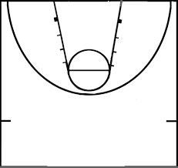

B

C

D

A

LOCATION:

|  |  |  |  |  |
| --- | --- | --- | --- | --- |
| A: | ____÷ 5 | = ____ | x 100 | = _____% |
| B: | ____÷ 5 | = ____ | x 100 | = _____% |
| C: | ____÷ 5 | = ____ | x 100 | = _____% |
| D: | ____÷ 5 | = ____ | x 100 | = _____% |

Questions:

1) Which location was your “hot spot”?

|  |
| --- |
|  |
|  |
|  |
|  |

2) Why do you think this what your “hot spot”?

|  |
| --- |
|  |
|  |
|  |
|  |

3) How would a coach and athlete use this information in a game scenario?

|  |
| --- |
|  |
|  |
|  |
|  |

Activity B:

* Take a piece of tape about 3 inches long
* Stand tall with your dominant arm side of your body tight against a wall
  + Your dominant side is the side of your body you use to write with
* Reach your dominant arm up as high as possible (keep both feet totally on the ground!) and place the tape on the wall.
* Take a small step away from the wall (so you don’t hit the wall while jumping!)
* Using another piece of tape, jump as high as possible, sticking the tape on the wall when you are at your highest point.
* Measure the difference between the two pieces of tape.
* Remove the tape from the wall.

Questions:

1) How high did you jump?

|  |
| --- |
|  |
|  |
|  |
|  |

2) Which way of measuring jump heigh is best? Using the device from the video, or with using tape? Why?

|  |
| --- |
|  |
|  |
|  |
|  |

***Activity Sheet #3: Hoop dancing***

* Task 1: Try spinning the hoop on your hand. Then stop the hoop and try spinning it the opposite direction.
* Task 2: Try spinning in a circle by yourself, with your arms in tight. Then stop and try spinning in the opposite direction.

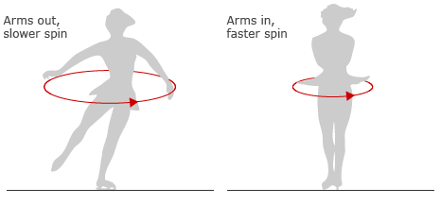

* Task 3: Try spinning in a circle by yourself, with your arms out wide. Then stop and try spinning in the opposite direction.

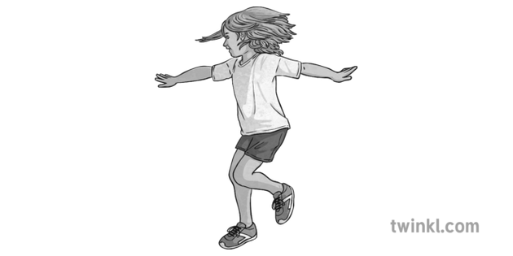 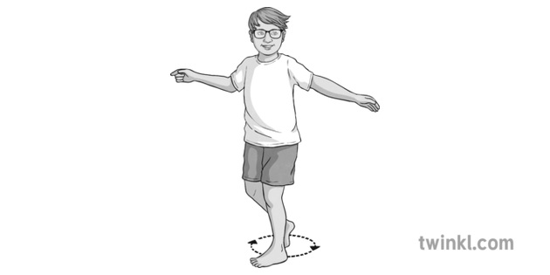

* Task 4: Now complete task 3 again but with a hula hoop in each hand.

 

Questions:

1) Which was easier: to get the hoop to start spinning on your hand or to keep the hoop spinning on your hand?

|  |
| --- |
|  |
|  |
|  |
|  |

2) Which was easier: to change spin direction while spinning with your hands out wide or tucked in?

|  |
| --- |
|  |
|  |
|  |
|  |

3) Which was easier: to change spin direction while spinning with your hoops out wide or with your hands out wide?

|  |
| --- |
|  |
|  |
|  |
|  |

4) During which spinning task was it hardest to start, stop, and change spin direction? Why?

|  |
| --- |
|  |
|  |
|  |
|  |